**Subject Curriculum Map**

**Maths – Fractions, Decimals and Percentages**

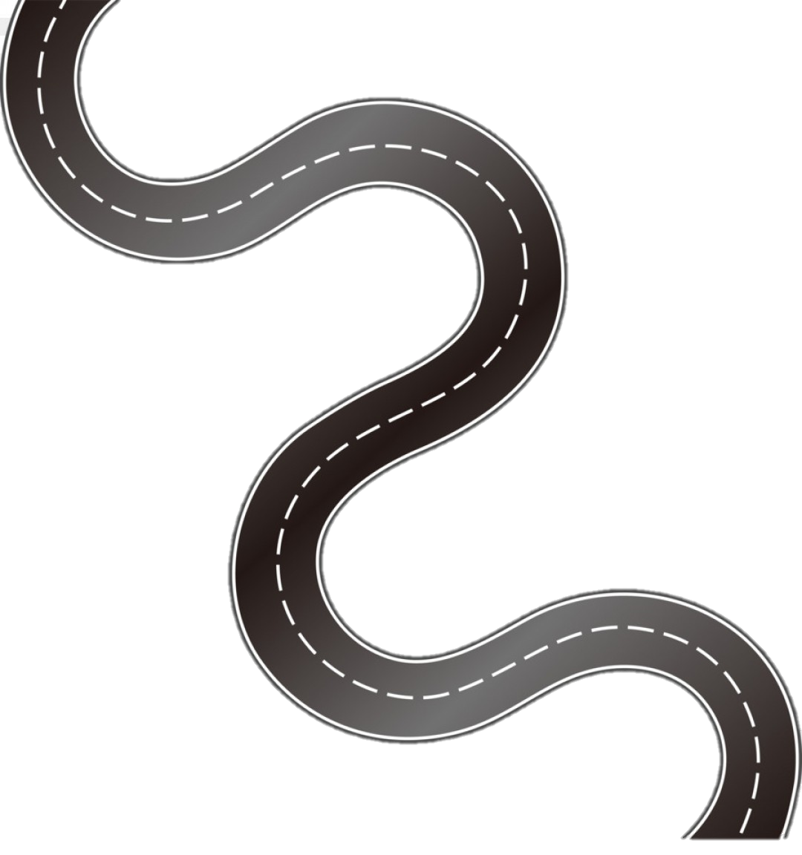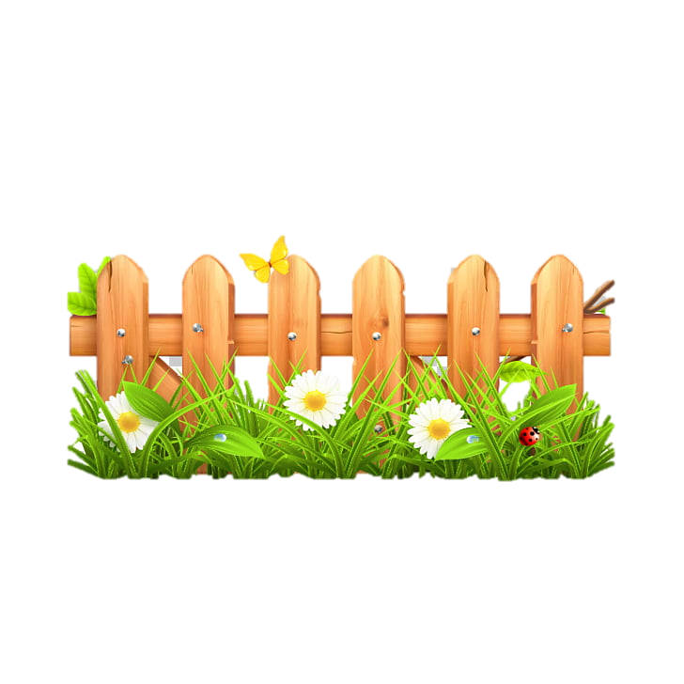

Year 6

* Read, write, order and compare numbers up to 10,000,000 and determine the value of each digit.

cv

Year 6

* Associate a fraction with division and calculate decimal fraction equivalents (for example 0.375) for a simple fraction (for example 3/8)
* Recall and use equivalences between simple fractions, decimals and percentages, including in different contexts.

Year 5

* Recognise the percent symbol (%) and understand that percent relates to ‘number of parts per hundred’, and write percentages as a fraction with denominator 100, and as a decimal.
* Solve problems which require knowing percentage and decimal equivalents of ½ ¼ 1/5 2/5 4/5 and those fractions with a denominator of a multiple of 10 or 25.

Year 4

* Solve simple measure and money problems involving fractions and decimals to two decimal places.

Year 1

Year 3

Year 2

**Upper KS2**

EYFS -

**Lower**

**KS2**

**KS 1**

**EYFS**

v