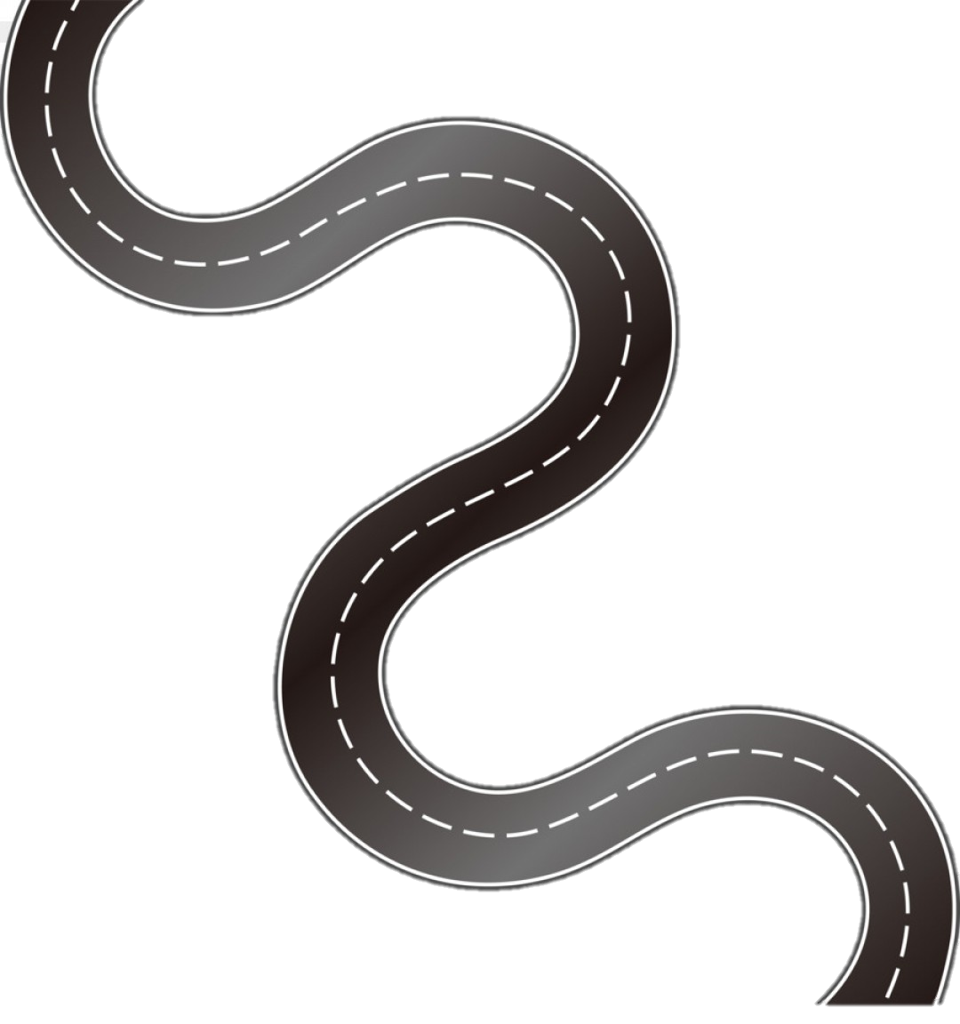

**Subject Curriculum Map**

**Maths – Geometry**

**(Angles and Lines)**

Year 6

* Read, write, order and compare numbers up to 10,000,000 and determine the value of each digit.

cv

Year 6

* Find unknown angles in any triangles, quadrilaterals, and regular polygons.
* Recognise angles where they meet at a point, are on a straight line, or are vertically opposite, and finding missing angles.

Year 5

* Know angles are measured in degrees: estimate and compare acute, obtuse and reflex angles.
* Draw given angles, and measure them in degrees.
* Identify angles at a point and one whole turn.
* Identify angles at a point on a straight line and half a turn.
* Identify other multiples of 90 degrees.

Year 4

* Identify acute and obtuse angles and compare and order angles up to right angles by size.
* Identify lines of symmetry in 2D shapes presented in different orientations.
* Complete a simple symmetric figure with respect to a specific line of symmetry.

Year 3

* Recognise angles as a property of shape or description of a turn.
* Identify right angles, recognise that two right angles make a half turn, three make three quarters of a turn and four a complete turn; identify whether angles are greater than or less than a right angle.
* Identify horizontal and vertical lines and pairs of perpendicular and parallel lines.

Year 2

Year 1

**Upper KS2**

EYFS -

**Lower**

**KS2**

**KS 1**

**EYFS**

v