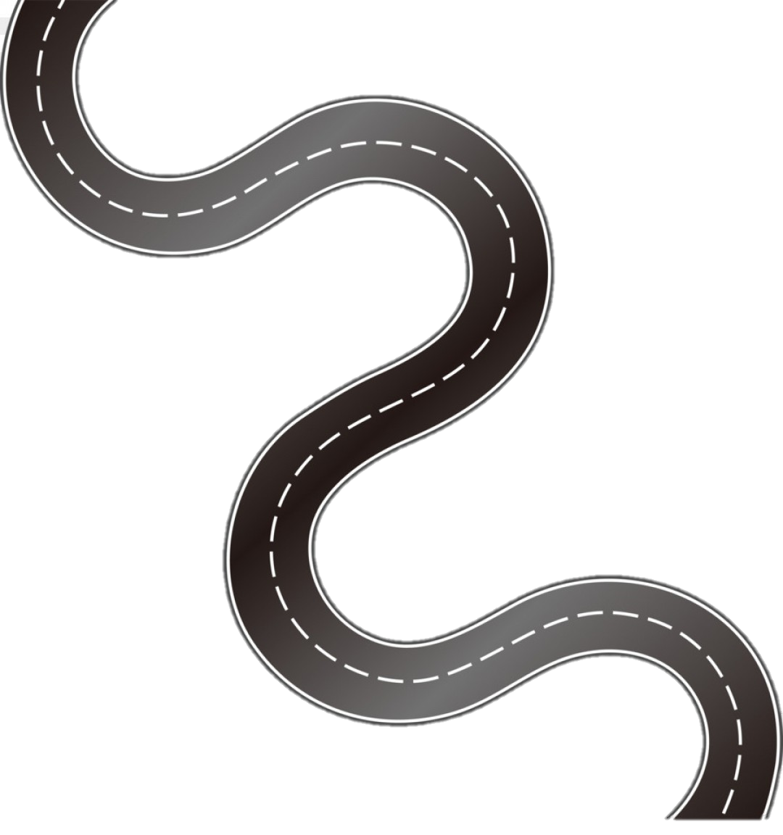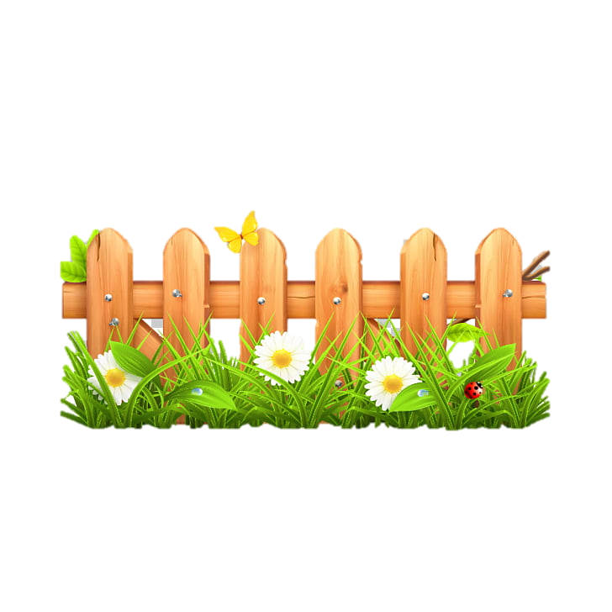

**Subject Curriculum Map**

**Maths – Measurement**

**(Perimeter, area and volume)**

Year 6

* Read, write, order and compare numbers up to 10,000,000 and determine the value of each digit.

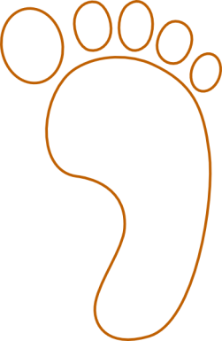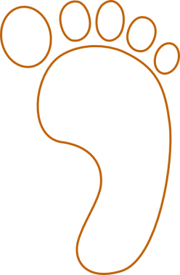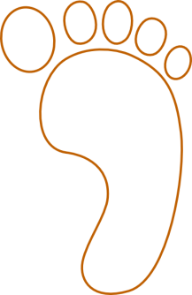cv

Year 6

* Recognise that shapes with the same areas can have different perimeters and vice versa.
* Recognise when it is possible to use formulae for area and volume of shapes.
* Calculate the area of parallelograms and triangles.
* Calculate, estimate and compare volume of cubes and cuboids using standard units, including cubic centimetres and cubic metres, and extending to other units (for example, millimetres cubed).

Year 5

* Measure and calculate the perimeter of composite rectilinear shapes in centimetres and metres.
* Calculate and compare the area of rectangles (including squares), and including using standard units, centimetres squared, metres squared, and estimate the area of irregular shapes.
* Estimate volume and capacity.

Year 4

* Measure and calculate the perimeter of a rectilinear figure (including squares) in centimetres and metres.
* Find the area of rectilinear shapes by counting squares.

Year 3

* Measure the perimeter of simple 2D shapes.

Year 2

Year 1

**Upper KS2**

EYFS -

**Lower**

**KS2**

**KS 1**

**EYFS**

v