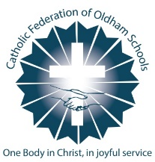
Catholic Federation of Oldham Schools
Supplementary Application Form
You will be asked to provide copies of baptism certificates and birth certificates.

Surname of child

Forenames of child

Date of birth

Gender

Address of child
(Please note proof may be required)

Postcode

Parent(s) Name(s)

Email address

Mobile telephone number

Landline telephone number

School(s) Applying for

Which Catholic Parish do you live in?

Religion

Are you able to produce a baptism certificate? | Catholic Baptism Certificate: Yes No  Christian Baptism Certificate: Yes No

Year group applying for and/or date of entry to Reception/Nursery class?

Is your child Looked After or Previously Looked After? | Yes No

Does your child have a statement of Special Educational Needs (SEN) or an Education Health and Care Plan (ECHP)? | Yes No

Does your child have an exceptional social, medical, educational or religious need which can be best met only at the school(s) that you are applying to? | Yes No

Does your child have a sibling in the school at the time of admission? | Yes No
Name of sibling(s):

Please ensure the form is returned to the Catholic school(s) to which you are applying.
You will still need to complete the Oldham Council Online Application Form.
For applicants for Reception Class, please ensure the form is returned to school before the Oldham LA admissions deadline date.
For oversubscription criteria, please refer to the Admission Policy on the school website.
CFOS Schools are GDPR compliant.
Signed: __________________________________________________ Date: _________________________

