Year 6

▪ Understand that many different devices can be used in isolation and sometimes together to produce digital ‘content’.

▪ Understand that you can convert between different formats of files.

**Computing Curriculum Map**

**Create, Manipulate and Manage Digital Content**

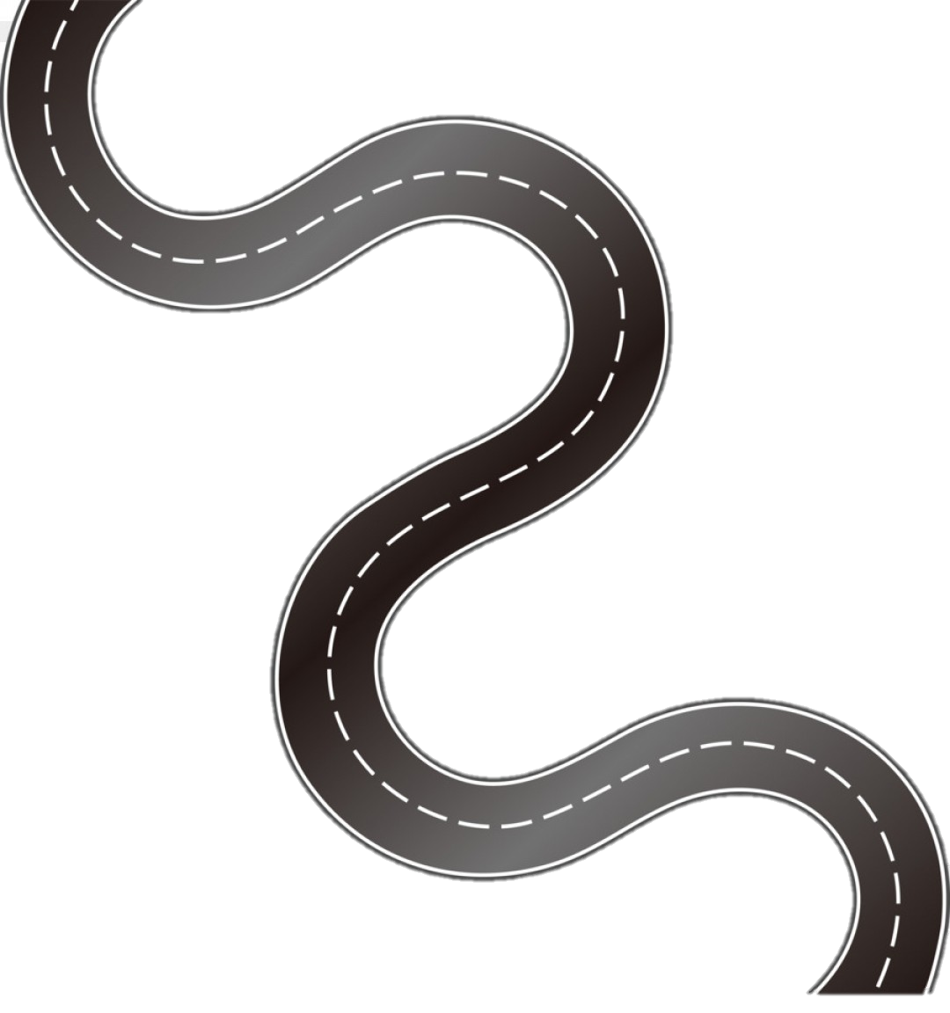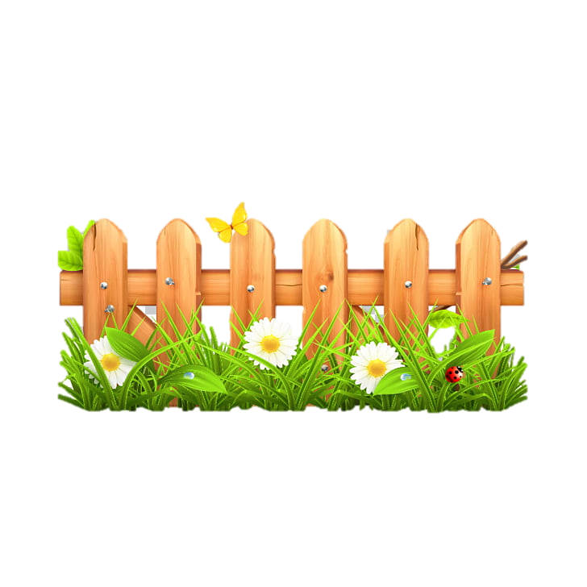

**EYFS**



**KS 1**



**Lower**

**KS2**

**Upper KS2**

c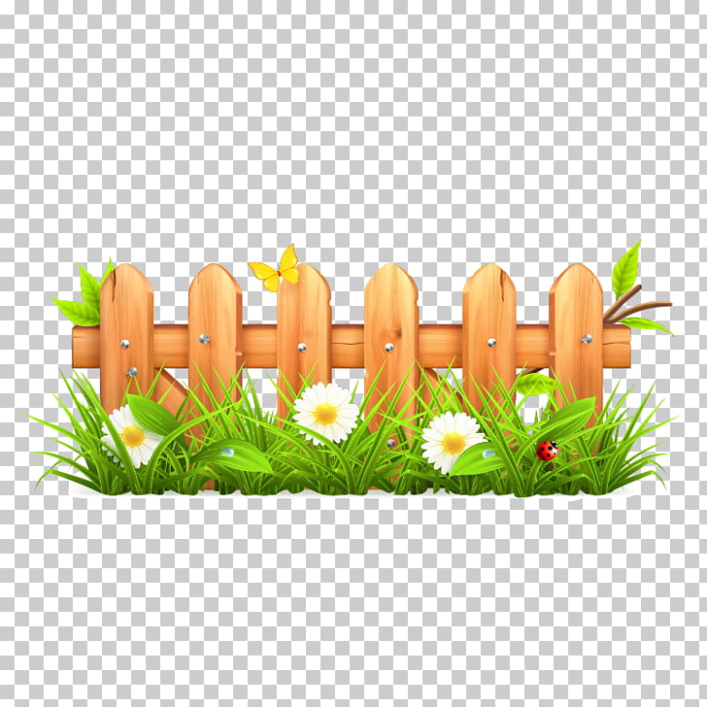v

Year 2

▪ Understand that animation is a sequence of still images.

▪ Know what the term multimedia means

▪ Save and store work in an appropriate are, and be able to retrieve and amend it.

▪ Start to understand that content needs to be changed according to the audience.

EYFS

Children recognise that a range of technology is used in places such as homes and schools. They select and use technology for particular purposes.

Year 5

▪ Understand the importance of content and editing to produce digital content for specific audiences.

Year 1

▪ Know that text can be different colours, sizes and styles and that these can easily be changed.

▪ Know that technology can be used to communicate ideas in different ways, e.g. text, images, tables and sound.

▪ Understand there are a variety of tools in graphics packages, each fulfilling a different purpose.

▪ Understand the differences between a graphics package and paper based art activities.

Year 4

▪ Recognise the features of good page design and multimedia presentations.

▪ Consider how design features meet the needs of the audience e.g. poster,

newspaper, menu, instructions.

Year 3

v