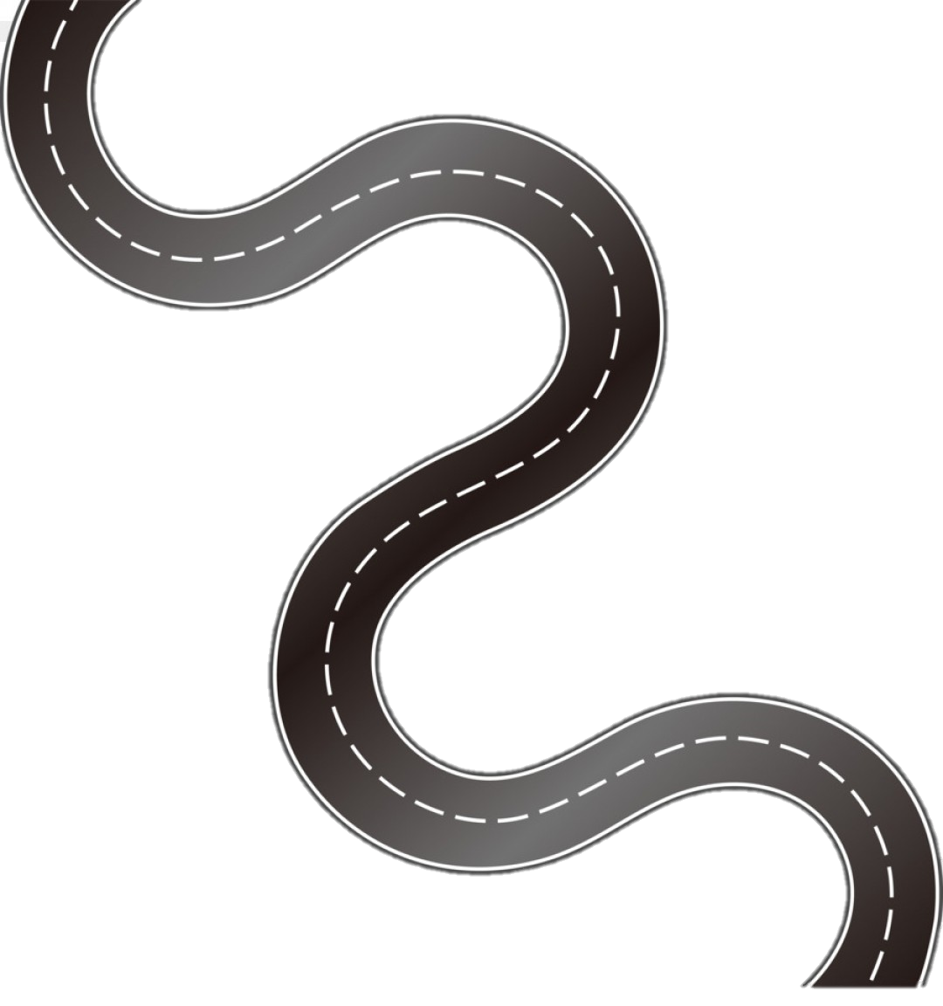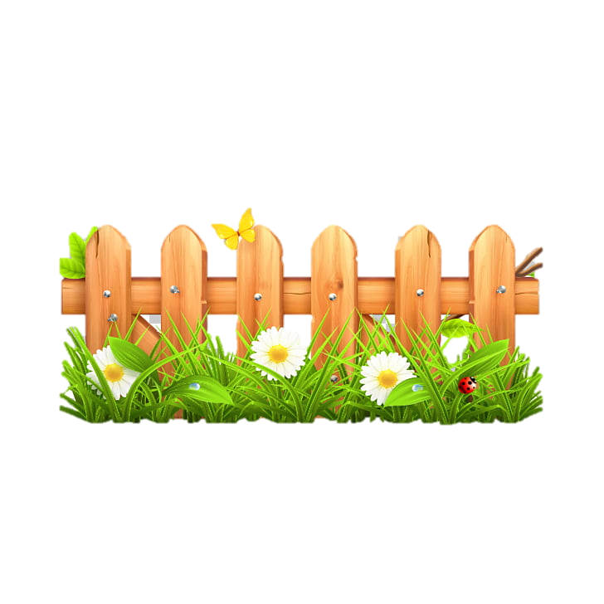

**Subject Curriculum Map**

**Maths – Geometry**

**(2D and 3D shapes)**

Year 6

* Read, write, order and compare numbers up to 10,000,000 and determine the value of each digit.

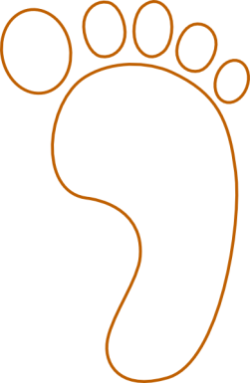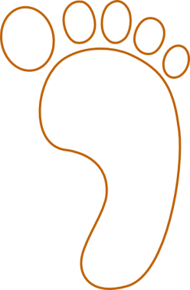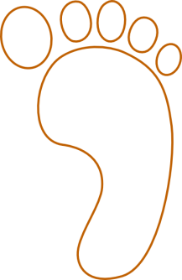cv

EYFS -

* Use positional language to describe how items are positioned in relation to other items e.g. over, under, around, through.
* Explore 3D shapes through block play and modelling.
* Encourage children to see 2D shapes on the flat faces of 3D shapes.
* Compare 2D shapes – what is the same and what is different?

Year 5

* Distinguish between regular and irregular polygons based on reasoning about equal sides and angles.
* Use the properties of rectangles to deduce related facts and find missing lengths and angles.

Year 6

* Draw 2D shapes using given dimensions and angles.
* Compare and classify geometric shapes based on their properties and sizes.
* Illustrate and name parts of circles, including radius, diameter and circumference and know that the diameter is twice the radius.

Year 4

* Compare and classify geometric shapes, including quadrilaterals and triangles, based on their properties and sizes.
* Identify lines of symmetry in 2D shapes presented in different orientations.

Year 3

* Draw 2D shapes.
* Make 3D shapes using modelling materials; recognise 3D shapes presented in different orientations.

Year 2

* Identify and describe the properties of 2D shapes, including the number of sides and line symmetry in a vertical line.
* Identify 2D shapes on the surface of 3D shapes (for example, a circle on a cylinder).
* Compare and sort common 2D shapes and everyday objects.
* Recognise and name common 3D shapes.
* Compare and sort common 3D shapes and everyday objects.

Year 1

* Recognise and name common 2D shapes.
* Recognise and name common 3D shapes (cuboids, cubes, pyramids and spheres).

**Upper KS2**

**Lower**

**KS2**

**KS 1**

**EYFS**

v