**Subject Curriculum Map**

**Maths – Measurement**

**(Money)**

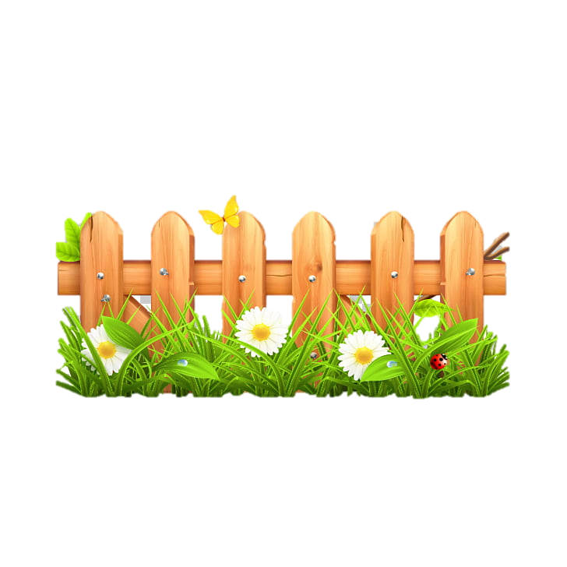

Year 6

* Read, write, order and compare numbers up to 10,000,000 and determine the value of each digit.

cv

Year 6

Year 5

* Use all four operations to solve problems involving measure (for example, money)

Year 3

* Add and subtract amounts of money to give change, using both £ and p in practical contexts.

Year 4

* Estimate, compare and calculate different measures, including money in pounds and pence.

Year 1

* Recognise and know the value of different denominations of coins and notes.

**Upper KS2**

Year 2

* Recognise and use symbols for pounds (£) and pence (p); combine amounts to make a particular value.
* Find different combinations of coins that equal the same amounts of money.
* Solve simple problems in a practical context involving addition and subtraction of money of the same unit, including giving change.

EYFS -

**Lower**

**KS2**

**KS 1**

**EYFS**

v