**Subject Curriculum Map**

**Maths – Measurement**

**(Time)**

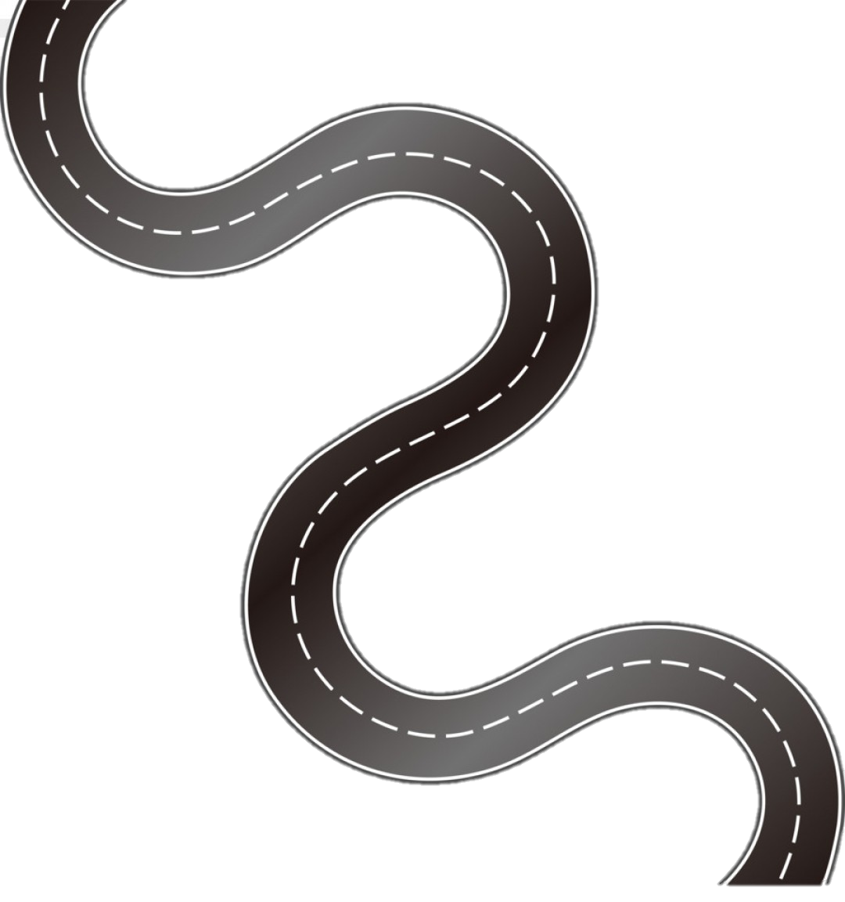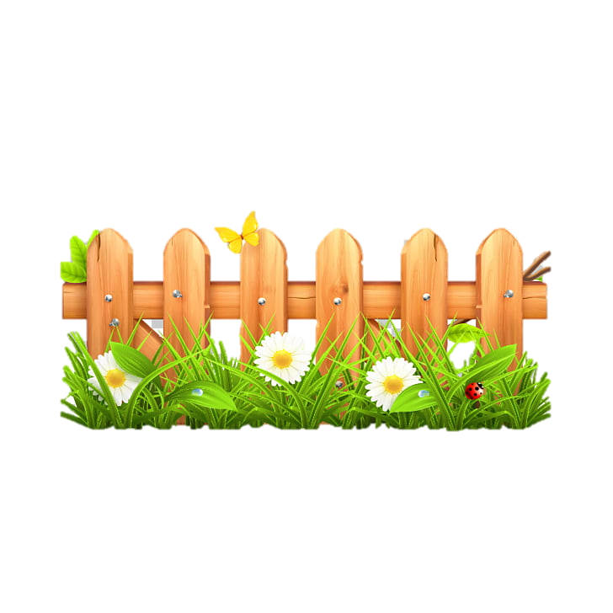

Year 6

* Read, write, order and compare numbers up to 10,000,000 and determine the value of each digit.

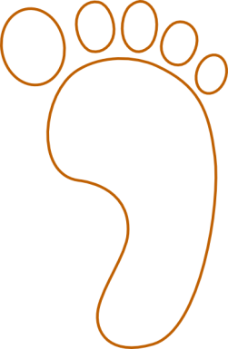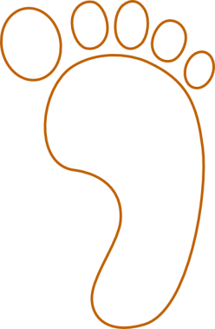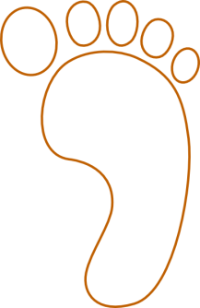cv

EYFS -

* Order important times in their day and use positional language to describe when events happen e.g. now, before, later, soon, yesterday, today, tomorrow.

Year 6

* Use, read, write and convert between standard units, converting measurements of time from a smaller unit of measure to a larger unit, and visa versa.

Year 5

* Solve problems involving converting between units of time.

Year 4

* Read, write and convert time between analogue and digital 12 and 24 hour clocks
* Solve problems involving converting from hours to minutes; minutes to seconds; years to months; weeks to days.

Year 3

* Tell and write the time from an analogue clock, including using Roman numerals from 1 to X11, and 12 hour and 24 hour clocks.
* Estimate and read time with increasing accuracy to the nearest minute; record and compare time in terms of seconds, minutes and hours; use vocabulary such as o’clock, a.m/p.m, morning, afternoon, noon and midnight.
* Know the number of seconds in a minute and the number of days in each month, year and leap year.
* Compare durations of events (for example, to compare the time taken by particular events or tasks).

Year 2

* Compare and sequence intervals of time.
* Tell and write the time to 5 minutes, including quarter to/past the hour and draw the hands on a clock face to show these times.
* Know the number of minutes in an hour and the number of hours in a day.

Year 1

* Sequence events in chronological order using language (for example, before and after, next, first, today, yesterday, tomorrow, morning, afternoon and evening).
* Recognise and use language relating to dates, including days of the weeks, months and years.
* Tell the time to the hour and half past the hour and draw the hands on a clock face to show these times.

**Upper KS2**

**Lower**

**KS2**

**KS 1**

**EYFS**

v