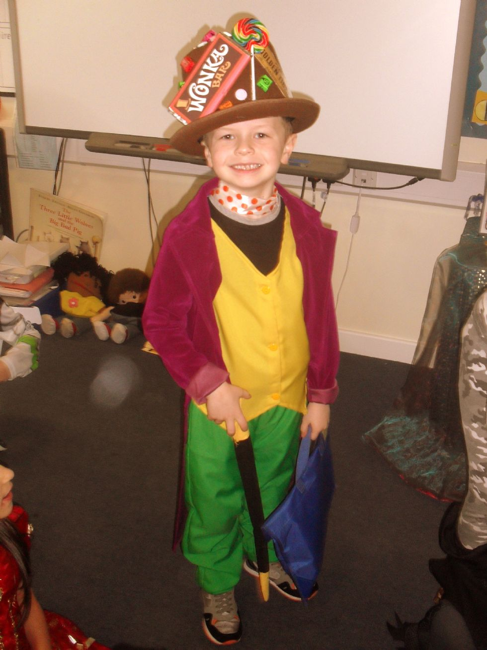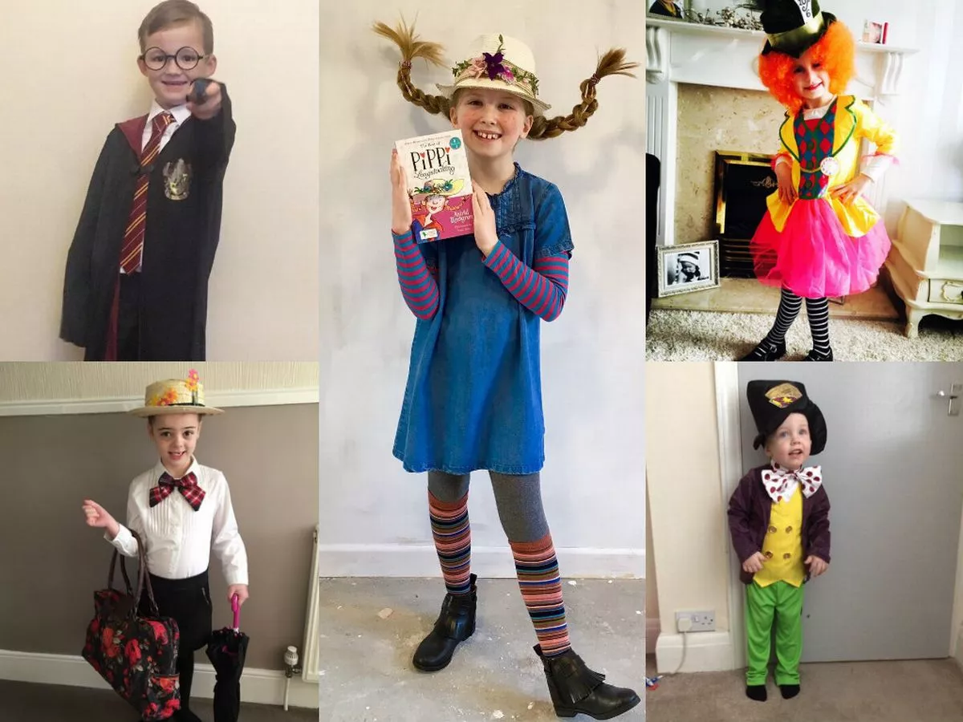

Head Stories

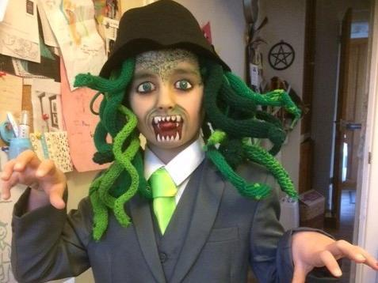

Share the stories that are in your **head**!

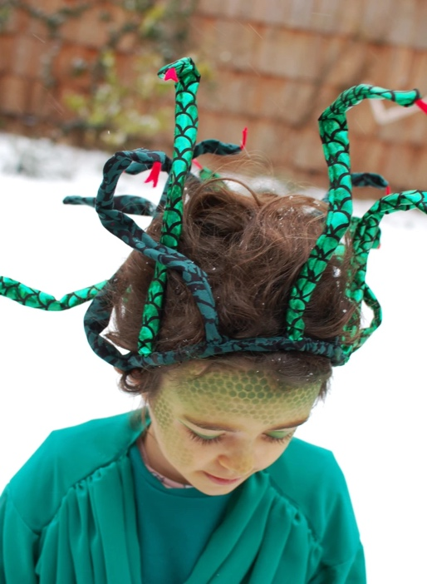

On Thursday 7th March, it is World Book Day and we are inviting children to come to school “wearing a story” and asking them to wear it on their head!

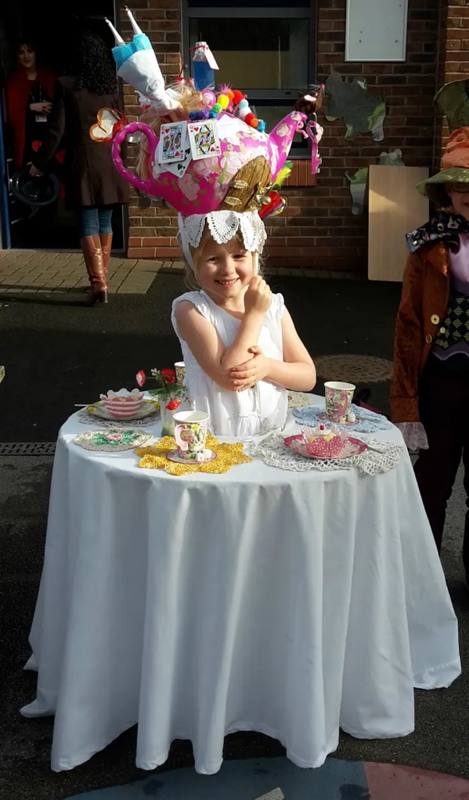

This could be a headband, wig, mask, hat etc and is to represent a character or story your child loves! It could even be your hair!!

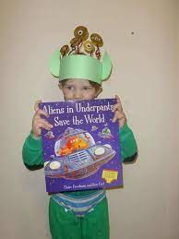

Prizes will be given for the best creation in each class.

We can’t wait to see your creations !!