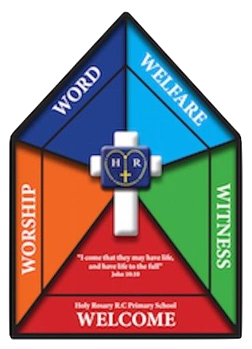
AUTUMN TERM
School re-opens | Wednesday 4th September 2024 | Autumn 1 –  38 School Days
School closes | Friday 25th October 2024
HALF-TERM
School re-opens | Monday 4th November 2024 | Autumn 2 –  35 School Days
School closes | Friday 20th December 2024
CHRISTMAS
SPRING TERM
School re-opens | Monday 6th January 2025 | Spring 1 –  29 School Days
School closes | Thursday 13th February 2025
HALF-TERM
School re-opens | Monday 24th February 2025 | Spring 2 –  39 School Days
School closes | Thursday 17th April 2025
EASTER
SUMMER TERM
School re-opens | Monday 28th April 2025 | Summer 1 –  19 School Days
School closed (Bank Holiday) | Monday 5th May 2025
School re-opens | Tuesday 6th May 2025
School closes | Friday 23rd May 2025
HALF-TERM
School re-opens | Monday 9th June 2025 | Summer 2 –  30 School Days
School closes | Friday 18th July 2025
Inset ( 5 Days )
Monday 2nd September 2024
Tuesday 3rd September 2024
Friday 14th February 2025
Monday 21st July 2025
Tuesday 22nd July 2025
In line with advice from the Department of Education, it is our duty to inform you that holidays should not be taken during school time and that to do so may result in you being fined.
PLEASE NOTE
Parents of Year 6 children must ensure that their child is in school during the statutory testing period. Dates to be confirmed.

